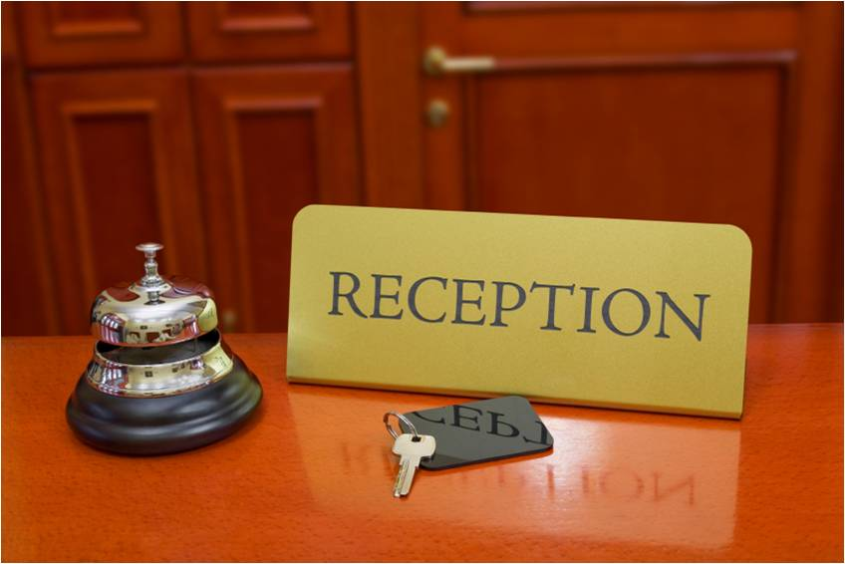

HOTEL MANAGEMENT SYSTEM

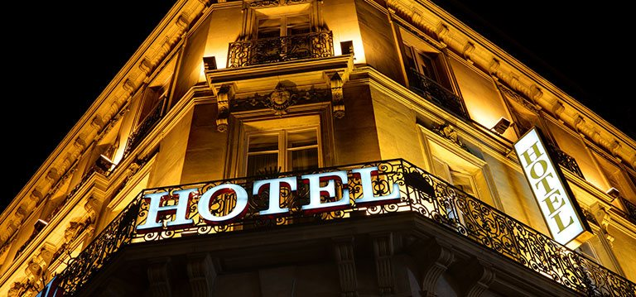

CERTIFICATE

THIS IS TO CERTIFY THAT INVESTIGATORY PROJECT SUCCESSFULLY COMPLETED BY Akshar Bansal OF CLASS XII-C.

ROLL.NO:__________________ FOR THE ACADEMIC YEAR 2019-20 IN THE SCHOOL COMPUTER LAB.

HEAD TEACHER:

EXTERNAL EXAMINER:

INTERNAL EXAMINER:

PRINCIPAL:

DATE: / / 20 DEPARTMENT OF: COMPUTER SCIENCE

CERTIFICATE

CLASS: XII-A

YEAR: 2019-20

THIS IS TO CERTIFY THAT INVESTIGATORY PROJECT IS SUCCESSFULLY COMPLETED BY NIKITA BHARDWAJ OF CLASS XII-A. ROLL.NO:_______________ FOR THE ACADEMIC YEAR 2019-20 IN THE SCHOOL COMPUTER LAB.

HEAD TEACHER:

EXTERNAL EXAMINER:

INTERNAL EXAMINER:

PRINCIPAL:

DATE: / / 20 DEPARTMENT OF: COMPUTER SCIENCE.

CERTIFICATE

CLASS: XII-A

YEAR: 2019-20

THIS IS TO CERTIFY THAT INVESTIGATORY PROJECT IS SUCCESSFULLY COMPLETED BY SAKSHI KINIKAR OF CLASS XII-A. ROLL.NO:____________ FOR THE ACADEMIC YEAR 2019-20 IN THE SCHOOL COMPUTER LAB.

HEAD TEACHER:

EXTERNAL EXAMINER:

INTERNAL EXAMINER:

PRINCIPAL:

DATE: / /20DEPARTMENT OF: COMPUTER SCIENCE.

CERTIFICATE

CLASS: XII-A

YEAR: 2019-20

THIS IS TO CERTIFY THAT INVESTIGATORY PROJECT IS SUCCESSFULLY COMPLETED BY NEESHITA YADAV OF CLASS XII-A. ROLL.NO:____________ FOR THE ACADEMIC YEAR 2019-20 IN THE SCHOOL COMPUTER LAB.

HEAD TEACHER:

EXTERNAL EXAMINER:

INTERNAL EXAMINER:

PRINCIPAL:

DATE: / /20DEPARTMENT OF: COMPUTER SCIENCE.

*ACKNOWLEDGEMENT*

I __________________ OF CLASS XII-A , ROLL.NO_________ WOULD LIKE TO EXPRESS MY SCIENCE GRATITUDE TO MY COMPUTER SCIENCE TEACHER MS. APARNA DHIRDE,PGT COMPUTER SCIENCE, FOR HER VITAL SUPPORT, GUIDANCE AND ENCOURAGEMENT- WITHOUT WHICH THIS PROJECT WOULD NOT HAVE COME FORTH.

I WOULD ALSO LIKE TO EXPRESS MY GRATITUDE TO MY SCHOOL KENDRIYA VIDYALAYA AMBARNATH FOR LETTING ME USE THE SCHOOL LABORATARY.

INDEX

1.BRIEF OVERVIEW OF PROJECT

2. NEED OF COMPUTERISATION

3. SOFTWARE AND HARDWARE REQUIREMENT

4. ADVANTAGES OF YOUR PROJECT

5. SOURCE CODE IN PYTHON

6. OUTPUT SCREENS

7.LIMITATIONS OF PROJECT

8.FUTURE ENHACEMENT OF PROJECT

9. BIBLIOGRAPHY

BRIEF OVERVIEW OF PROJECT

The Hotel Management system is togeneralize andsimplify the monthly or day today activities of Hotel-like Room activities ,Check –in of New Customer ,Checkout of customer ,Assigning a room according to customer requirement ,and finally compute the bill etc. which has to be performed repeatedly on regular basis.

To provide efficient , fast, reliable and user-friendly system is the basic motto behind this exercise .And show the Hotel room facilities, Book room. The main aim of the entireactivity is to automatetheprocess of day to dayactivities of Hotellike Room activities, Admission of a New Customer, Assign a roomaccording to customer’s demand, checkout of a computerand releasing theroom andfinally compute thebill etc.

*NEED OF COMPUTERISATION*

*Computers are used extensively by lodging managers and their assistants to keep track of guests’ bills, reservations, room assignments, meetings, and special events. In addition, computers are used to order food, beverages, and supplies, as well as to prepare reports for hotel owners and top-level managers. Many hotels also provide extensive information technology services for their guests. Managers work with computer specialists and other information technology specialists to ensure that the hotel’s computer systems, Internet, and communications networks function properly.*

*2) There are many different uses for computers in hotels. The first would be at the front desk. These computers have an intricate soft -ware called the Property Management System (PMS) to do all the check ins, guest accounting, and etc. The most famous being Opera or Sabre. Second in the restaurant, lounge, or bar is a new computer entirely called a Point of Sale System (POS). This will collaborate with a PMS to bill guests for a meal and etc. but can also be used as a cash register. Third is the computer in the sales office, which software is most likely DelPhi which is a booking terminal*.

HARDWARE AND SOFTWARE REQUIREMENTS

HARWARE:

1.OPERATING SYSTEM: SUPPORTS ALL KNOWN OPERATING SYSTEMS, SUCH AS WINDOWS,LINUX.

2. COMPUTER: 512MB+ RAM, MONITOR WITH MINIMUM RESOLUTION OF 1024x768, KEYBOARD AND MOUSE.

3.HARD DRIVE: SHOULD BE IN NTFS FILE-SYSTEM FORMATTED WITH MINIMUM 10 GB OF FREE SPACE.

SOFTWARE:

1. SOFTWARE IS DESIGNEDTO RUN ON ANY PLATFORM ABOVE MICROSOFT WINDOWS
2. 27MICROSOFT, NET FRAMEWORKS 4.0 OR ABOVE.

3. MICROSOFT SQL SERVER MANAGEMENT STUDIO- EXPRESS 2010.

ADVANTAGES

1. Sometime it happens that the rooms get booked soon when one visitsthe place therefore user can make advance booking using this system.

It saves user time in searching a room.

2.The system is useful as it calculates an exact cost of rooms for requested number of days.

3.It saves organization resources and expenses.

4.This system is effective and saves time and cost of users*.*

DISAVANTAGES

* The booking process usually requires a customer identity, which the system cannot detect.
* It requires a reliable internet connection*.*

FUTURE ENHACEMENT OF PROJECT.

This project can be used in the hotel after adding some more useful modules in the project for which hotel are providing services.Utmost care and back-up procedures must be established to ensure 100% successful implementation of the computerized hotel system. In case of system failure, the organization should be in a position to process the transaction with another organization if the worst comes to the worst, it should be in a position to complete it manually.

BIBLIOGRAPHY

1. [www.slideshare.net](http://www.slideshare.net)
2. [www.quora.com](http://www.quora.com)
3. UNDER THE GUIDENCE OF OUR SUBJECT TEACHER.

